Composite Solids with Multiple Flat and Curved Surfaces

Definition
# Source: AI Source: Provided by: [Data Path: Persons Table -> ID Column: 1, Name_En Column: Motasem Essam] -> From: [ChatGPT] on [7/25/2026]
Multiple Flat and Curved Surfaces are composite solids whose external boundaries contain several planar faces and several curved surfaces. These surfaces belong to two or more solid components joined together to form one three-dimensional object.
The curved surfaces may include cylindrical, conical, spherical, hemispherical, ellipsoidal, or toroidal surfaces. The flat surfaces may include rectangular, square, triangular, circular, polygonal, or other planar faces.
A composite solid in this category has a combination of multiple flat and curved surface types rather than just one flat surface type and one curved surface type.

Simple Definition
# Source: AI Source: Provided by: [Data Path: Persons Table -> ID Column: 1, Name_En Column: Motasem Essam] -> From: [ChatGPT] on [7/25/2026]
A solid formed by combining different three-dimensional shapes so that its outside boundary contains multiple flat faces and multiple curved surfaces.

Geometric Representation
# Source: AI Source: Provided by: [Data Path: Persons Table -> ID Column: 1, Name_En Column: Motasem Essam] -> From: [ChatGPT] on [7/25/2026]
A composite solid may contain the following surface types:
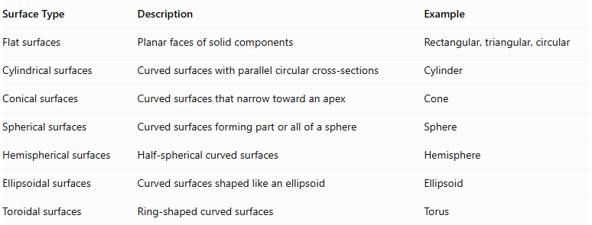
Surface Type | Description | Example
Flat surfaces | Planar faces of solid components | Rectangular, triangular, circular
Cylindrical surfaces | Curved surfaces with parallel circular cross-sections | Cylinder
Conical surfaces | Curved surfaces that narrow toward an apex | Cone
Spherical surfaces | Curved surfaces forming part or all of a sphere | Sphere
Hemispherical surfaces | Half-spherical curved surfaces | Hemisphere
Ellipsoidal surfaces | Curved surfaces shaped like an ellipsoid | Ellipsoid
Toroidal surfaces | Ring-shaped curved surfaces | Torus
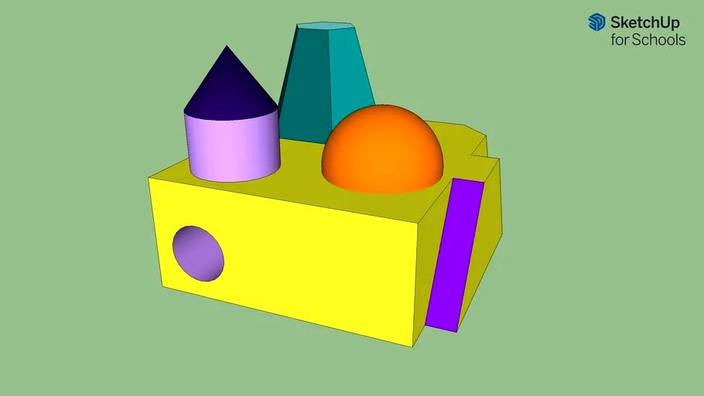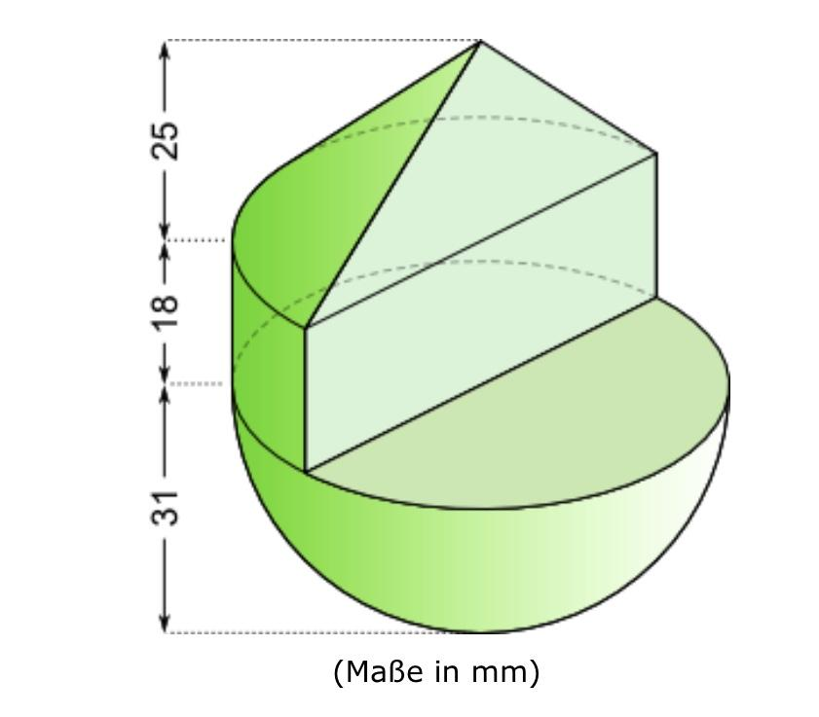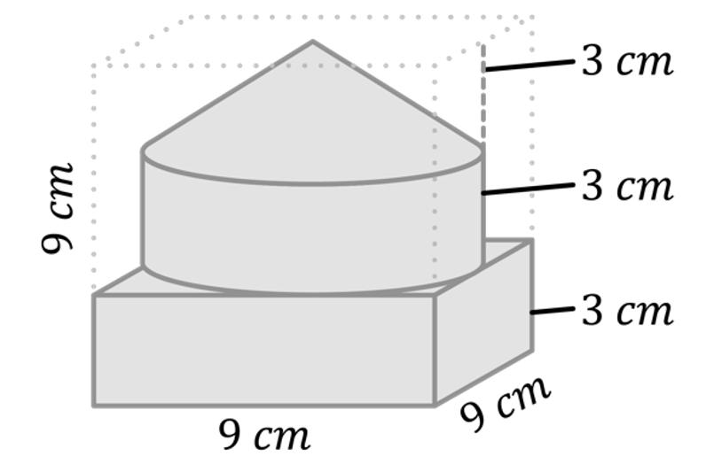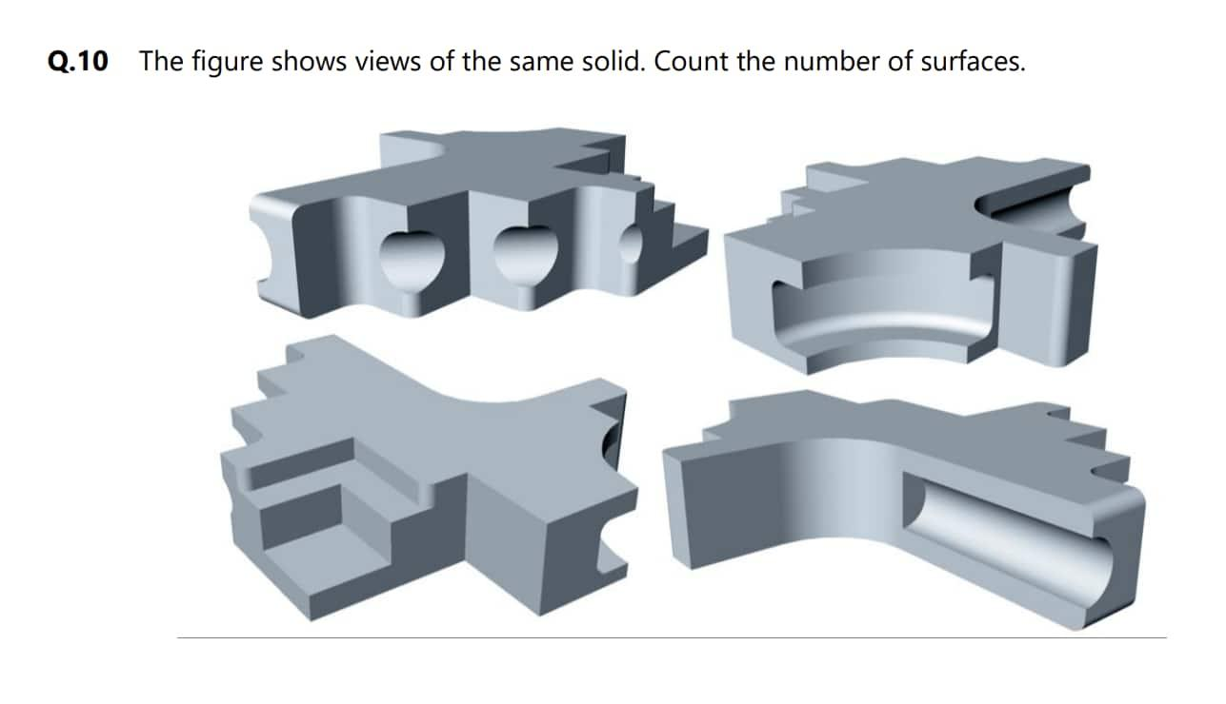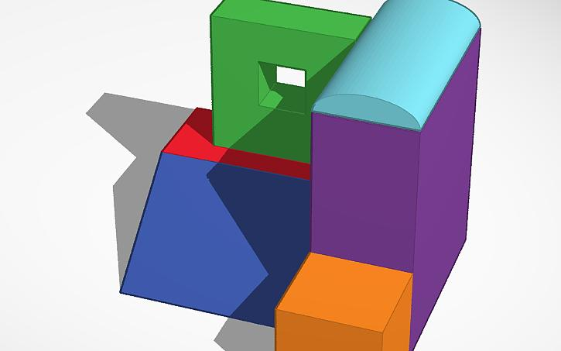

Main Classification
# Source: AI Source: Provided by: [Data Path: Persons Table -> ID Column: 1, Name_En Column: Motasem Essam] -> From: [ChatGPT] on [7/25/2026]
Multiple flat and curved surfaces can be classified according to the curved surface types combined with the planar faces.

Multiple Flat and Cylindrical Surfaces
# Source: AI Source: Provided by: [Data Path: Persons Table -> ID Column: 1, Name_En Column: Motasem Essam] -> From: [ChatGPT] on [7/25/2026]
A composite solid containing several flat faces and multiple cylindrical curved surfaces.
Examples:
- A rectangular prism with multiple cylinders attached to different faces.
- A prism supporting two or more cylindrical components.
- A stepped solid with several cylindrical extensions.
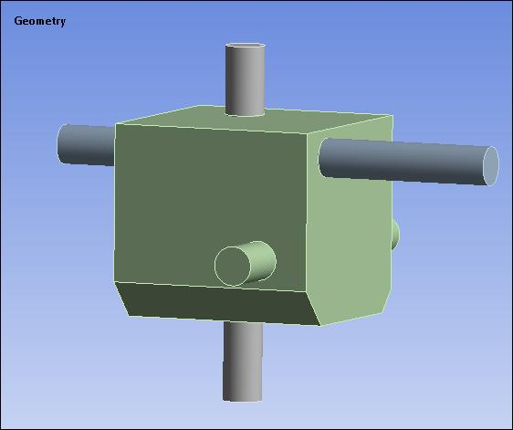

Multiple Flat and Conical Surfaces
# Source: AI Source: Provided by: [Data Path: Persons Table -> ID Column: 1, Name_En Column: Motasem Essam] -> From: [ChatGPT] on [7/25/2026]
A composite solid containing several flat faces and multiple conical curved surfaces.
Examples:
- A rectangular prism with multiple cones attached to its upper face.
- A polygonal base supporting several conical components.
- A stepped solid with multiple conical extensions.
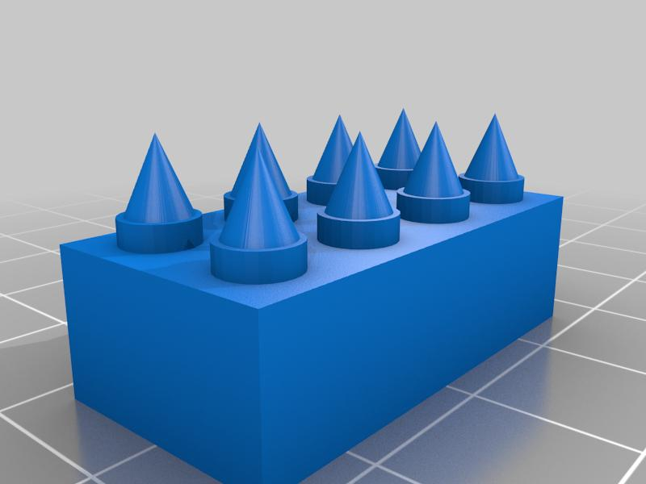

Multiple Flat and Spherical Surfaces
# Source: AI Source: Provided by: [Data Path: Persons Table -> ID Column: 1, Name_En Column: Motasem Essam] -> From: [ChatGPT] on [7/25/2026]
A composite solid containing several flat faces and multiple spherical curved surfaces.
Examples:
- A rectangular prism with multiple spheres attached to its faces.
- A polygonal solid with several spherical extensions.
- A block containing multiple spherical protrusions.
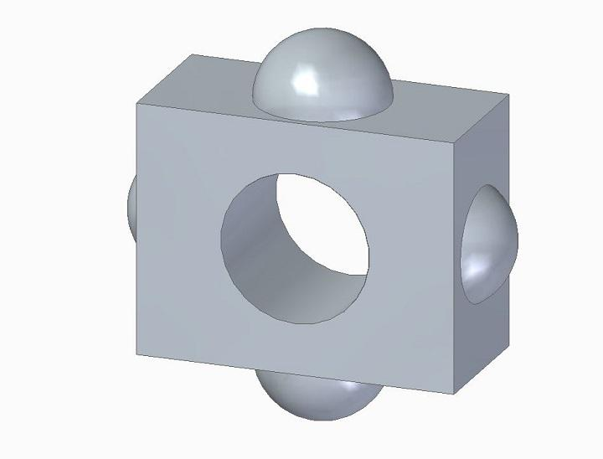

Multiple Flat and Hemispherical Surfaces
# Source: AI Source: Provided by: [Data Path: Persons Table -> ID Column: 1, Name_En Column: Motasem Essam] -> From: [ChatGPT] on [7/25/2026]
A composite solid containing several flat faces and multiple hemispherical curved surfaces.
Examples:
- A rectangular prism with several hemispherical caps.
- A cylindrical structure with multiple hemispherical extensions.
- A flat-faced base supporting multiple hemispherical components.
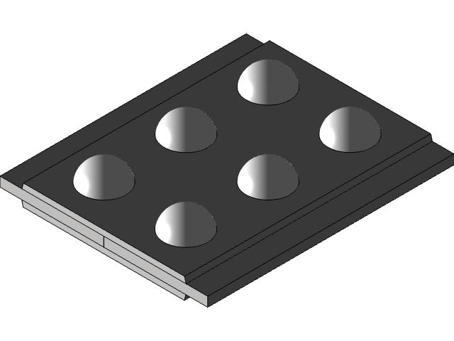

Multiple Flat and Ellipsoidal Surfaces
# Source: AI Source: Provided by: [Data Path: Persons Table -> ID Column: 1, Name_En Column: Motasem Essam] -> From: [ChatGPT] on [7/25/2026]
A composite solid containing several flat faces and multiple ellipsoidal curved surfaces.
Examples:
- A rectangular base with multiple ellipsoidal extensions.
- A polygonal solid with ellipsoidal protrusions.
- A structure combining planar components with elongated ellipsoidal components.
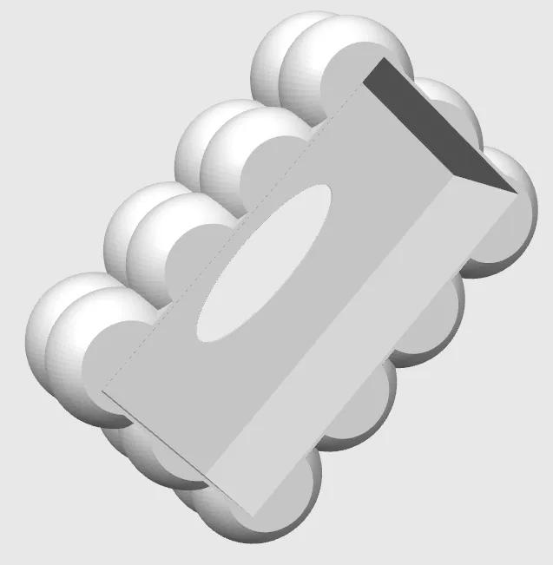

Multiple Flat and Toroidal Surfaces
# Source: AI Source: Provided by: [Data Path: Persons Table -> ID Column: 1, Name_En Column: Motasem Essam] -> From: [ChatGPT] on [7/25/2026]
A composite solid containing several flat faces and multiple toroidal curved surfaces.
Examples:
- A rectangular base supporting multiple ring-shaped toroidal components.
- A polygonal solid combined with several toroidal extensions.
- A structure with flat platforms and multiple ring-shaped curved sections.
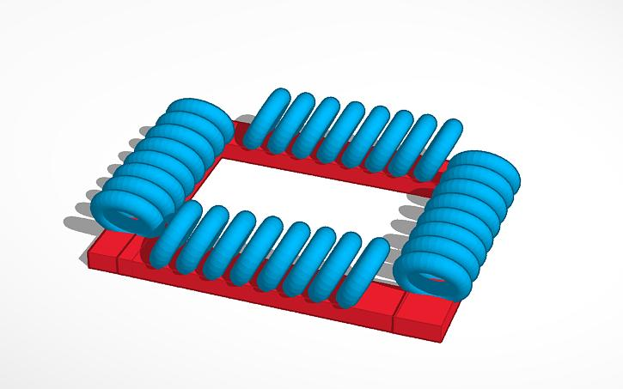

Multiple Flat and Mixed Curved Surfaces
# Source: AI Source: Provided by: [Data Path: Persons Table -> ID Column: 1, Name_En Column: Motasem Essam] -> From: [ChatGPT] on [7/25/2026]
A composite solid containing several planar faces and multiple different types of curved surfaces.
The curved surfaces may include combinations of:
- Cylindrical and conical surfaces.
- Cylindrical and spherical surfaces.
- Conical and hemispherical surfaces.
- Cylindrical, conical, and spherical surfaces.
- Spherical, ellipsoidal, and toroidal surfaces.
Examples:
- A rectangular prism with cylindrical supports, conical extensions, and spherical caps.
- A stepped structure combining cylinders, cones, and hemispheres.
- A complex solid combining several different curved components with a polygonal base.

Classification by Number of Curved Surface Types
# Source: AI Source: Provided by: [Data Path: Persons Table -> ID Column: 1, Name_En Column: Motasem Essam] -> From: [ChatGPT] on [7/25/2026]
Another way to classify these solids is by the number of different curved surface types present.
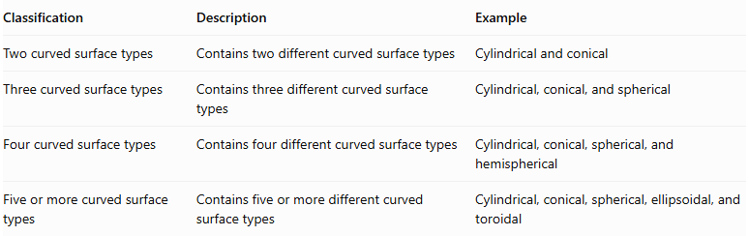
Classification | Description | Example
Two curved surface types | Contains two different curved surface types | Cylindrical and conical
Three curved surface types | Contains three different curved surface types | Cylindrical, conical, and spherical
Four curved surface types | Contains four different curved surface types | Cylindrical, conical, spherical, and hemispherical
Five or more curved surface types | Contains five or more different curved surface types | Cylindrical, conical, spherical, ellipsoidal, and toroidal
This classification counts distinct curved surface types, not the number of individual curved surfaces.

Classification by Number of Components
# Source: AI Source: Provided by: [Data Path: Persons Table -> ID Column: 1, Name_En Column: Motasem Essam] -> From: [ChatGPT] on [7/25/2026]
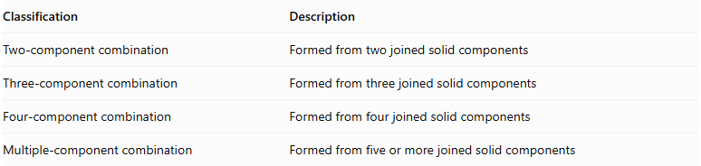
Classification | Description
Two-component combination | Formed from two joined solid components
Three-component combination | Formed from three joined solid components
Four-component combination | Formed from four joined solid components
Multiple-component combination | Formed from five or more joined solid components
A component may contribute one or more flat or curved surfaces to the final composite solid.

Mathematical Properties and Formulas
# Source: AI Source: Provided by: [Data Path: Persons Table -> ID Column: 1, Name_En Column: Motasem Essam] -> From: [ChatGPT] on [7/25/2026]
The mathematical properties depend on the dimensions, arrangement, and joining regions of the component solids.

Volume
# Source: AI Source: Provided by: [Data Path: Persons Table -> ID Column: 1, Name_En Column: Motasem Essam] -> From: [ChatGPT] on [7/25/2026]
For components joined without overlapping interiors:
$$V_{total}=V_{1}+V_{2}+⋯+V_{n}$$
If the components overlap, the overlapping volume must be subtracted to avoid double-counting.
Common volume formulas:
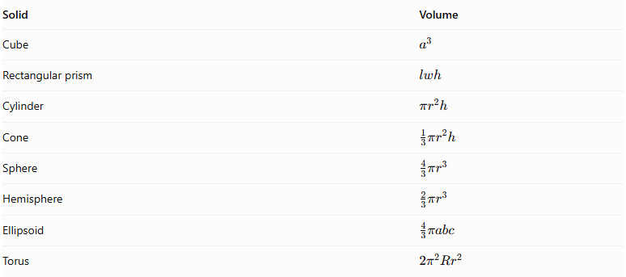
Solid | Volume
Cube | $$a^{3}$$
Rectangular prism | $$lwh$$
Cylinder | $$πr^{2}h$$
Cone | $$\frac{1}{3}πr^{2}h$$
Sphere | $$\frac{4}{3}πr^{3}$$
Hemisphere | $$\frac{2}{3}πr^{3}$$
Ellipsoid | $$\frac{4}{3}πabc$$
Torus | $$2π^{2}{Rr}^{2}$$

Surface Area
# Source: AI Source: Provided by: [Data Path: Persons Table -> ID Column: 1, Name_En Column: Motasem Essam] -> From: [ChatGPT] on [7/25/2026]
The total external surface area is the sum of the areas of all exposed surfaces:
$${SA}_{external}=\sum{{SA}_{exposed flat}}+\sum{{SA}_{exposed curved}}$$
When two components are joined through complete matching planar faces:
$${SA}_{external}=\sum{{SA}_{individual}}-2\sum{A_{joining}}$$
For partial contacts or curved intersections, calculate the actual hidden and exposed regions individually. Do not automatically subtract twice an entire face.

Common Surface Area Formulas
# Source: AI Source: Provided by: [Data Path: Persons Table -> ID Column: 1, Name_En Column: Motasem Essam] -> From: [ChatGPT] on [7/25/2026]
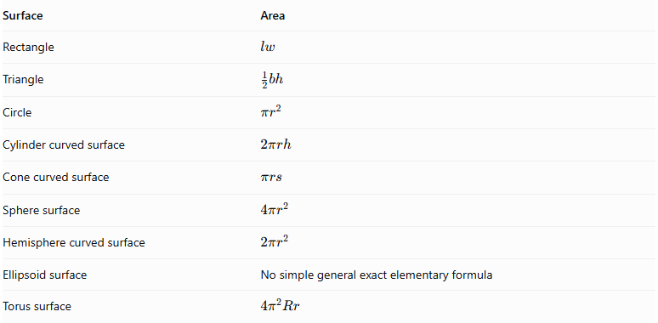
Surface | Area
Rectangle | $$lw$$
Triangle | $$\frac{1}{2}bh$$
Circle | $$πr^{2}$$
Cylinder curved surface | $$2πrh$$
Cone curved surface | $$πrs$$
Sphere surface | $$4πr^{2}$$
Hemisphere curved surface | $$2πr^{2}$$
Ellipsoid surface | No simple general exact elementary formula
Torus surface | $$4π^{2}Rr$$
Where:
- $r$ = radius.
- $R$ = major radius of a torus.
- $s$ = cone slant height.
- $a,b,c$ = ellipsoid semi-axis lengths.

Worked Examples

Example 1: Rectangular Prism, Two Cylinders, and Two Cones
# Source: AI Source: Provided by: [Data Path: Persons Table -> ID Column: 1, Name_En Column: Motasem Essam] -> From: [ChatGPT] on [7/25/2026]
A composite solid consists of:
- One rectangular prism: $10×8×6$.
- Two cylinders, each with radius $2$ and height $3$.
- Two cones, each with radius $2$ and height $3$.
Assume the components are attached without overlapping interiors, with each cylinder attached to a separate flat region and each cone attached to a cylinder through its circular base. All joining regions are completely hidden.
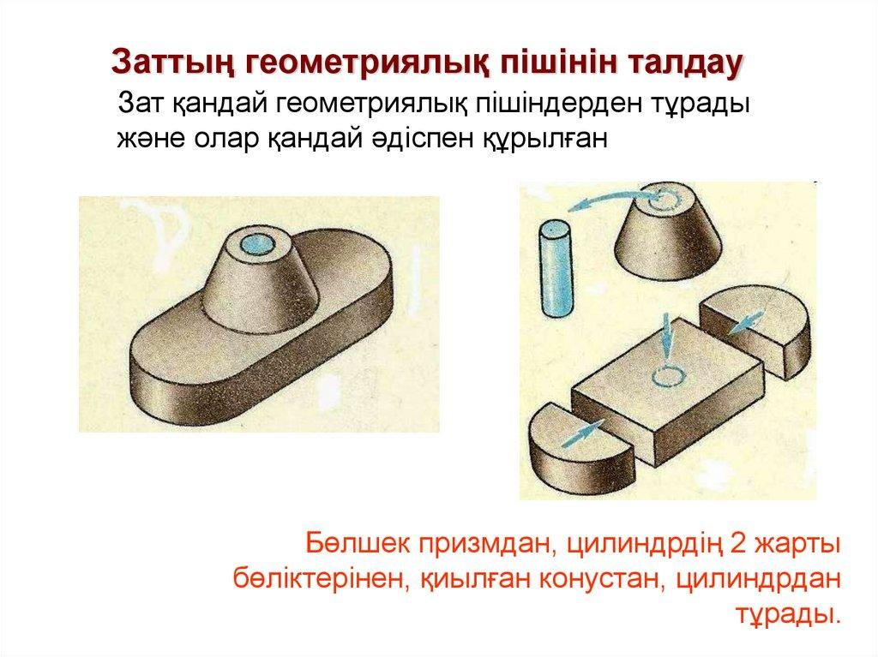
Step 1: Calculate the prism volume.
$$V_{1}=10×8×6=480$$
Step 2: Calculate the total cylinder volume.
$$V_{2}=2(πr^{2}h)$$
$$=2(π×2^{2}×3)=24π$$
Step 3: Calculate the total cone volume.
$$V_{3}=2(\frac{1}{3}πr^{2}h)$$
$$=2(\frac{1}{3}×π×2^{2}×3)=8π$$
Step 4: Calculate total volume.
$$V=480+24π+8π$$
$$\boxed{V=480+32π≈580.53}$$

Example 2: Rectangular Prism, Cylinder, Hemisphere, and Cone
# Source: AI Source: Provided by: [Data Path: Persons Table -> ID Column: 1, Name_En Column: Motasem Essam] -> From: [ChatGPT] on [7/25/2026]
A composite solid consists of:
- A rectangular prism: $12×10×6$.
- A cylinder: $r=2, h=4$.
- A hemisphere: $r=2$.
- A cone: $r=2, h=3$.
Assume the components are joined consecutively through circular planar bases, with each circular joining region fully hidden and no overlap.
Step 1: Calculate the prism volume.
$$V_{1}=12×10×6=720$$
Step 2: Calculate the cylinder volume.
$$V_{2}=π(2)^{2}(4)=16π$$
Step 3: Calculate the hemisphere volume.
$$V_{3}=\frac{2}{3}π(2)^{3}=\frac{16π}{3}$$
Step 4: Calculate the cone volume.
$$V_{4}=\frac{1}{3}π(2)^{2}(3)=4π$$
Step 5: Calculate total volume.
$$V=720+16π+\frac{16π}{3}+4π$$
$$\boxed{V=720+\frac{76π}{3}≈799.59}$$

Important Characteristics
# Source: AI Source: Provided by: [Data Path: Persons Table -> ID Column: 1, Name_En Column: Motasem Essam] -> From: [ChatGPT] on [7/25/2026]
- Multiple planar faces: The solid has several flat surfaces, which may have different shapes and dimensions.
- Multiple curved surfaces: It contains more than one curved surface, potentially of different geometric types.
- Complex geometry: Its overall shape is more complex than a basic solid.
- Component-based structure: It is formed from two or more solid components.
- Hidden joining regions: Some component surfaces become internal or hidden when solids are connected.
- Variable surface combinations: The curved surfaces may be cylindrical, conical, spherical, hemispherical, ellipsoidal, or toroidal.
- Independent dimensions: Each component may have different dimensions and proportions.

Comparison with Other Types
# Source: AI Source: Provided by: [Data Path: Persons Table -> ID Column: 1, Name_En Column: Motasem Essam] -> From: [ChatGPT] on [7/25/2026]
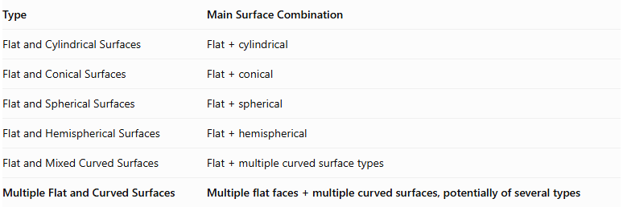
Type | Main Surface Combination
Flat and Cylindrical Surfaces | $$Flat+cylindrical$$
Flat and Conical Surfaces | $$Flat+conical$$
Flat and Spherical Surfaces | $$Flat+spherical$$
Flat and Hemispherical Surfaces | $$Flat+hemispherical$$
Flat and Mixed Curved Surfaces | $$Flat+multiplecurvedsurfacetypes$$
Multiple Flat and Curved Surfaces | Multiple flat faces + multiple curved surfaces, potentially of several types

Applications
# Source: AI Source: Provided by: [Data Path: Persons Table -> ID Column: 1, Name_En Column: Motasem Essam] -> From: [ChatGPT] on [7/25/2026]
- Architectural structures combining flat walls, cylindrical columns, and curved roofs.
- Mechanical components containing planar bases and curved extensions.
- Industrial equipment with cylindrical, conical, and spherical sections.
- Decorative sculptures combining different geometric solids.
- Storage and processing equipment with multiple curved sections.
- Complex engineering models and three-dimensional CAD designs.

Key Points
# Source: AI Source: Provided by: [Data Path: Persons Table -> ID Column: 1, Name_En Column: Motasem Essam] -> From: [ChatGPT] on [7/25/2026]
- Multiple Flat and Curved Surfaces describe composite solids with several planar and curved external surfaces.
- The curved surfaces can belong to the same or different geometric types.
- A solid may contain multiple cylinders, cones, spheres, hemispheres, ellipsoids, or toruses.
- Classification can be based on surface types, the number of different curved surface types, or the number of components.
- Volume is calculated by adding component volumes when there is no overlap.
- Surface area includes only exposed surfaces; hidden joining regions must be excluded.

Conclusion
# Source: AI Source: Provided by: [Data Path: Persons Table -> ID Column: 1, Name_En Column: Motasem Essam] -> From: [ChatGPT] on [7/25/2026]
Multiple Flat and Curved Surfaces represent a broad category of composite solids formed by combining several flat-faced and curved solid components. They can contain multiple instances of the same curved surface type or combinations of different curved surface types. Their classification and mathematical analysis depend on the number, geometry, arrangement, and joining regions of their components.

